1.Write a query to display the name (first_name, last_name) and salary for all employees whose salary is not in the range $10,000 through $15,000

select first_name ,last_name ,salary from employee_details where salary not between "10000" and "15000";

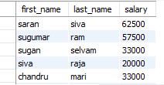

2.Write a query to display the name (first_name, last_name) and department ID of all employees in departments 30 or 100 in ascending order.

select first_name,last_name,dept_it from employee_details where dept_it in (30 ,100);

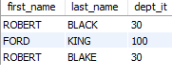

select first_name,last_name,hire_date from employee_details where year(hire_date) like '1987%';

select first_name,last_name,hire_date from employee_details where year(hire_date) like '1987%';

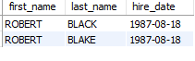

4.Write a query to display the first_name of all employees who have both "b" and "c" in their first name

select first_name from employee_details where first_name like 'B%'or first_name like 'C%';



5.Write a query to display the last name of employees whose names have exactly 6 characters.

select last_name from employee_details where last_name like'______';



6.Write a query to select all record from employees where last name in 'BLAKE', 'SCOTT', 'KING' and 'FORD'

select *from employee_details where last_name in ('BLAKE', 'SCOTT', 'KING' ,'FORD');

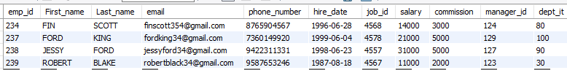

7.Write a query to list the number of jobs available in the employees table.

select count(distinct job_id) from employee_details;

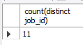

8.Write a query to get the highest, lowest, sum, and average salary of all employees.

select max(salary) as Highestsalary,min(salary)as lowestsalary,sum(salary)as totalsalary,round(avg(salary),0) as averagesalary from employee_details;



9.Write a query to find the manager ID and the salary of the lowest-paid employee for that manager

select manager_id ,min(salary)from employee_details ;



10.Write a query to get the department ID and the total salary payable in each department.

select dept_it,sum(salary) from employee_details group by dept_it;

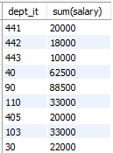

 11.Write a query to get the minimum salary from employees table.

select min(salary)from employee_details;

